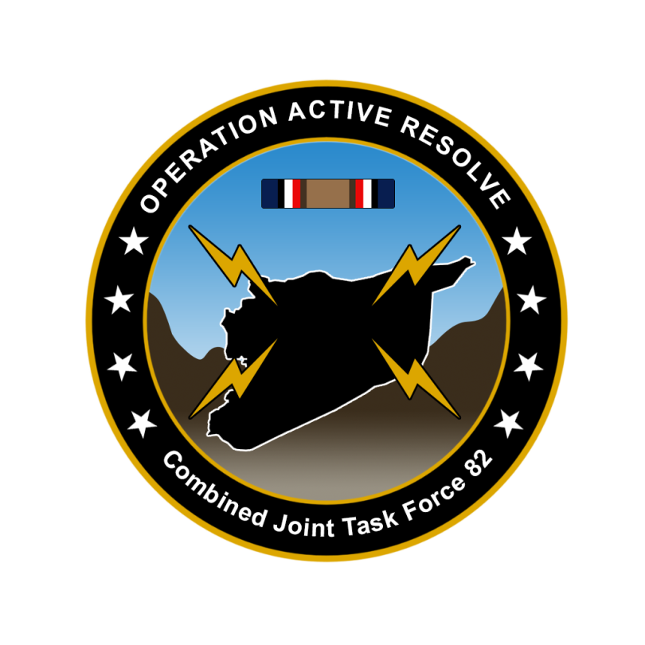

CJTF-82 DIRECTION AND GUIDANCE

D4

This document covers the friendly situation from D2 and provides CJTF-82 guidance to the entire force for D3.

**Reference CombatFlite**: <https://github.com/132nd-vWing/OPAR-Brief/raw/master/COMBATFLITE/OPAR%20Friendly%20situation.cf>

# SITUATION

## General situation

September 1st 2011 (D1) JFACC initiated airstrikes against Syrian forces while LCC started preparing its offensive. During D2 JFACC have continued engagements toward Syrian forces in Syria and in the occupied territory. Turkish local forces have been heavily engaged against Syrian forces IVO the Ataturk Dam, and despite support by CAS assets the area have fallen to Syrian hands.

## Friendly situation

### Land Component Command (LCC)

#### IV Corps

55th Mechanized Division has secured HATAY and have moved forward battalions to screening positions along the FLOT.

56th Armor Division have its forward elements at the outskirt of Gaziantep. 56th is preparing for the assault at Gaziantep airfield that will commence in the morning hours of D4.

#### Turkish local forces

* The Turkish 33rd Brigade protecting the Ataturk Dam have been defeated by Syrian forces despite heavy resistance and support from JFACC with CAS.
* Turkish local forces are in static defensive positions and are not in a position to assume offensive operations.
* Turkish local forces consist of BTR-80 and M-113s vehicles
* Turkish local forces are reinforced with coalition JTACs to support with CAS to defend against Syrian attacks.

### Maritime Component Command (MCC)

* CSG-1 continues to support the mission from CSG-1 operations box.
* SAG 1 have been directed to head west in the Mediterranean due to sinking of a ship carrying ordnance for JFACC.

### Joint Force Air Component Command (JFACC)

* IAW JFACC JAOP.

### Special Operations Component Command (SOCC)

* SOF teams are standing by to support with reconnaissance as required and requested by JFACC.
* SOF teams are also on standby to conduct counter terrorism missions and counter insurgency operations.

# Reported Battle Damage Assessment D2

## IV Corps Northern Sector

* NSTR

## Turkish ground forces.

* Turkish ground forces have reported that two Syrian companies of combat vehicles have been destroyed by ground forces in the fight of Ataturk Dam. (This is in addition to everything destroyed by JFACC during CAS operations).

# Logistical situation

* The US ship with 50 GBU-38s is currently in transit in the strait of Suez. The ship is expected to come out of the Suez channel on D3, and is planning to offload munitions at Iskenderun on the morning of D4.

# Direction and Guidance

## LCC:

* Priority of effort is on 56th Armored Division attack at Gazientep.
* Prepare plan for phase 2
  + Submit CONOP (Concept of Operations) to CJTF HQ for approval
  + CONOP submitted NLT D+8

## MCC:

* BPT move CSG-1 operations box based on JFACC needs.
* Use SAG-1 to protect shipping in the western Mediterranean.

## JFACC:

* Priority of effort is on establishing Air Superiority in support of LCC and set conditions for own operations.
* Start shaping for phase 2 in the operation (Create permissive environment).
* Continue support to LCC
* Be prepared to prepare contingency plans for striking Syrian WMD at short notice (regardless of phase). Expect this plan to be asked for prior to commencing phase 2.
  + ALR: EXTREME approved for such a plan.
* JFC are working with political leaders to get an agreement to use airbases in Iraq during parts of phase 2. Airbases in question are H3, H3 Northwest. H3 Southwest. JFACC can at some point start contingency planning for using these airbases (Need ATC charts, coordinate with 176th), how can the airbases be used to best support JFACC (what squadrons to be based there?), what targets, or what can be achived by using these bases. We do not have a time estimate, but it will not happen until Phase 2 at the earliest.

## VIS:

* Support JFACC planning and execution
* Be prepared to support JFACC with creating contingency plan for striking Syrian WMD at short notice.

## Diplomatic situation

* Syria is declared as enemy
* Russia is declared as adversary
* Jordan is declared as neutral
* Lebanon is declared as neutral
* Turkey is declared as friendly
* Israel is declared as neutral
* China is declared as adversary
* Iran is declared as adversary
* Iraq is declared as neutral

Only units declared as enemy can and should be engaged by CJTF forces.

**Definitions:**

Enemy: is actively opposed or hostile to CJTF and friendly forces.

Adversary: opponent in a contest, conflict, or dispute toward CJTF and friendly forces.

Neutral: not supporting or helping either side in a conflict, disagreement, etc.; impartial.